Position details
Group: | Customer Experience and Communications
Branch: | Communications
Team: | Corporate Affairs
Reports to: | Head of Corporate Affairs
Position No: | 40006
Classification: | 7
Financial management | $643,991
Direct reports: | 2 FTE
Volunteers being supervised by this position: | Nil
Job Family: | Communications

Our vision and the way we work
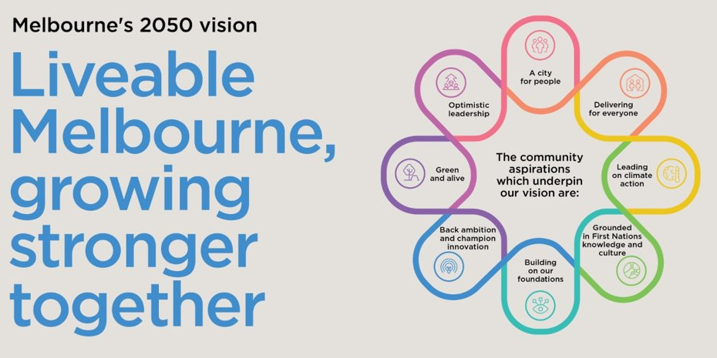

The way we work is underpinned by our values:
- INTEGRITY is being honest and reliable in all dealings with others and conducting activities professionally and ethically.
- COURAGE means to step out of our own comfort zone and accept responsibility for the consequences of our own actions.
- ​​​​​ACCOUNTABILITY means to take personal responsibility for decisions and actions to achieve agreed outcomes.
- RESPECT means to value the contribution and individuality of others and contribute to healthy working relationships.
- EXCELLENCE means we aim to achieve the highest standard and best possible result in everything we do.

Team context
Communications Branch
The Communications branch supports the City of Melbourne (CoM) through clear, timely and effective communications. It helps position CoM, strengthen its reputation and communicate our strategic priorities to key audiences.
The branch leads CoM’s internal and external communications, strategic communications, advocacy, partnerships, corporate brand and reputation management.
Working across the organisation, the branch develops and promotes content aligned with CoM’s priorities across internal and external channels. It also anticipates and responds to emerging and critical issues that could affect the organisation’s reputation.
The branch supports advocacy with other levels of government and external organisations and works closely with other local governments on shared priorities.
Corporate Affairs Team
The Corporate Affairs team shapes and strengthens the City of Melbourne’s reputation and keeps our people informed and engaged. Across four key functions – media, social media, internal communications and corporate communications – we communicate Council priorities, manage issues and reputation, tell our stories and deliver clear, timely information to internal and external audiences.
Position purpose
The Manager, Internal Communications is responsible for leading the delivery of clear, engaging communications that keep our workforce informed and connected to the City of Melbourne’s priorities.
The role leads the planning, delivery and measurement of internal content, campaigns and timely staff updates across multiple channels – with a strong focus on digital communications, reaching and engaging our frontline workforce, and improving the overall staff experience.
Working closely with leaders and teams across the organisation, the Manager provides expert communications advice, strengthens staff engagement and supports major organisational change and key initiatives.
The role also builds internal communications and engagement capability across the organisation, helping teams communicate effectively with their people and supporting changes to policy, programs and ways of working.
Key accountabilities
Leadership expectations

All City of Melbourne (CoM) People Leaders are influential and values-driven leaders who play a critical role in delivering the Council Plan and People Strategy. They are responsible for:

- Leading with Purpose, Values and Ethics: Embedding CoM’s values and demonstrating ethical leadership in all decisions and actions. Leading with purpose, integrity and care to build trust, model accountability, and create a positive, high-performance culture.
- Building an Inclusive and Supportive Workplace: Creating and sustaining a culture where people feel safe, supported and empowered to do their best work. Modelling behaviours that foster belonging, inclusion, and wellbeing in line with CoM’s Inclusion, Equity and Diversity (IED) Framework and Safe & Thriving Workplace priorities.
- Empowering People and Developing Capability: Attracting, developing and retaining talented people who share our ambition to be a leading organisation for a leading city. Coaching, mentoring and empowering team members to grow capability, demonstrate accountability, and achieve excellence in outcomes.
- Driving Performance and Accountability: Setting clear expectations, aligning team goals to the Council Plan and People Strategy, and delivering measurable results. Creating a culture of continuous improvement, feedback and innovation.
- Stewardship of Resources: Managing people, budgets and resources efficiently and responsibly to maximise value and deliver sustainable outcomes for the organisation and the community.
- Collaboration and Partnership: Working constructively across divisions, with partners and stakeholders, to deliver integrated, people-centred solutions that reflect the priorities of the Council Plan and our community.

- Leading clear, timely and engaging staff communications that connect our workforce to City of Melbourne priorities and support delivery of our strategy.
- Building strong relationships with Executives and senior leaders to strengthen workforce engagement and support organisational change.
- Planning and delivering high-impact internal campaigns that build understanding, engagement and support for major initiatives and change.
- Leading and improving our internal communications channels, with a strong focus on digital communications and better reaching frontline and non-desk-based staff.
- Advising and coaching leaders and teams on effective communication and engagement, building capability across the organisation.
- Providing strategic advice to CoM leadership on complex and high-risk issues, organisational change and projects that impact staff.
- Overseeing high-quality internal content, collaborating closely with PCS, the CEO’s Office and other communications teams, and using data and insights to measure impact and continuously improve.
- Supporting broader priority communications activities as required.

Key relationships
Internal | External
- CEO’s office  - People, Culture & Safety  - Communications branch | - Nil

Key selection criteria
All CoM employees will demonstrate an ability to articulate and demonstrate benefits of positive culture and values.
In addition, the position will require:
- A relevant tertiary qualification in communications, media or business with sound knowledge of change management.
- Highly developed communication skills and demonstrated extensive relevant experience in developing and executing integrated communications strategies.
- Substantial experience in providing advice on matters of high organisational risk and the development of communications solutions to rapidly evolving issues.
- A demonstrated ability to evaluate the effectiveness of communication strategies and implement evidence-based improvements over time.
- Ability to thrive in a fast-paced and dynamic environment, including the ability to lead a small team and communicate with influence to senior CoM officers, including the CEO.
- Well-developed management skills with the ability to cultivate a team that integrates seamlessly with other work areas and operates with emotional intelligence and sound judgement on complex and high-risk initiatives.
- Proven ability to function effectively in a complex and demanding environment, with a high level of personal and team responsibility, and to effectively manage high workloads, tight timelines, and significant and diverse relationships.
- Ability to build and maintain strategic relationships with all key stakeholders to achieve successful internal communications outcomes for CoM’s strategic priorities.
- Excellent written communication skills across all mediums.

Inherent requirements
The reference to the Inherent Physical Requirements for this position is DM# 9234862

Commitment to child safety
All staff at The City of Melbourne are required to have a valid Working with Children Check (WWCC)
The City of Melbourne is a child-safe organisation with zero tolerance for child abuse. All children and young people have the right to be and feel safe. We embed child safety into daily practice and require all employees, volunteers and contractors to understand, prevent, detect and report any concerns relating to child safety.

